Create Service Connector Hub with ORM Stack

Contents

1. Introduction 1
2. Workflow diagram to deploy the stack 1
3. Create stack for Service Connector Hub 2
4. Plan the Job 6
5. Apply the Job 7
6. Verify in the Console 9
7. Destroy the stack (if required) 9

Introduction

Use the Service Connector Hub service to transfer data between services in Oracle Cloud Infrastructure.

Service Connector Hub is a cloud message bus platform that offers a single pane of glass for describing, executing, and monitoring interactions when moving data between Oracle Cloud Infrastructure services.

Workflow diagram to deploy the stack

Below diagram shows how the Terraform Artifact are applied in the OCI. While creating a ORM stack, using terraform deliverables Init, Plan and Apply is the flow to provision the resource in the OCI. We can have the deliverables in any of below.
- GitLab/GitHub Repo
- Bitbucket
- Can be in folder/.zip in the local disk
- Object Storage Bucket
- Can be in compartment
- Oracle provided Template


Create stack for Service Connector Hub

Go to OCI Console Developer Services Resource Manager Stacks select the compartment Create Stack

My Configuration Folder Browse Select the “Service Connector” folder that contains the artifacts Upload

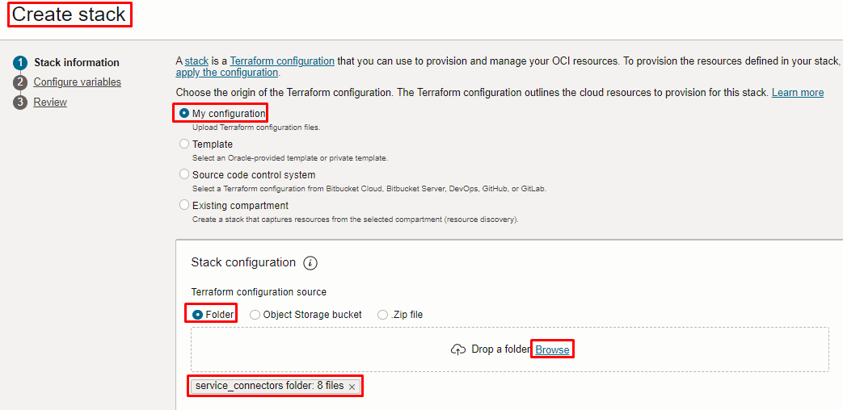
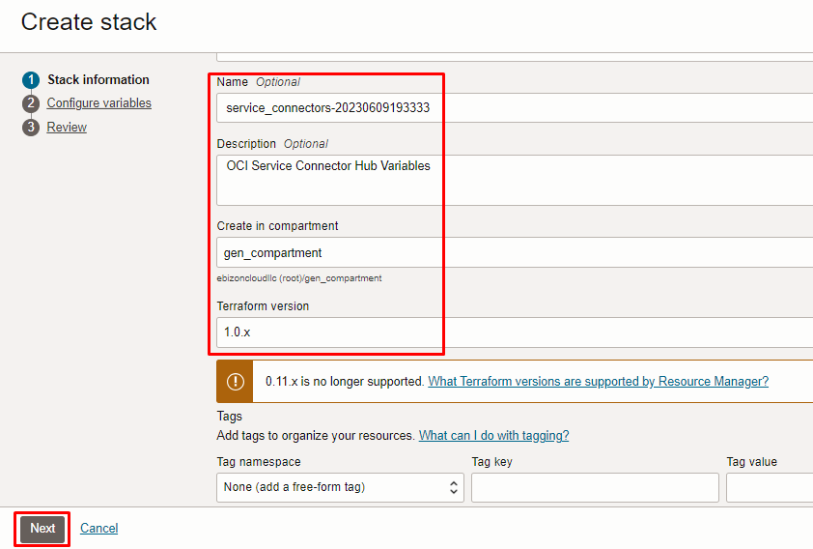

Click “NEXT”

Select the parameters as per the below screen,

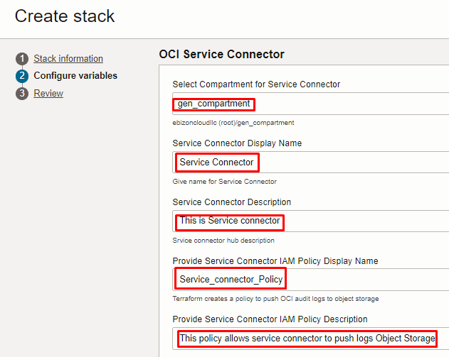

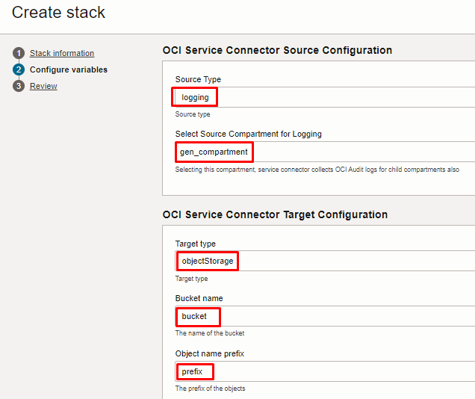
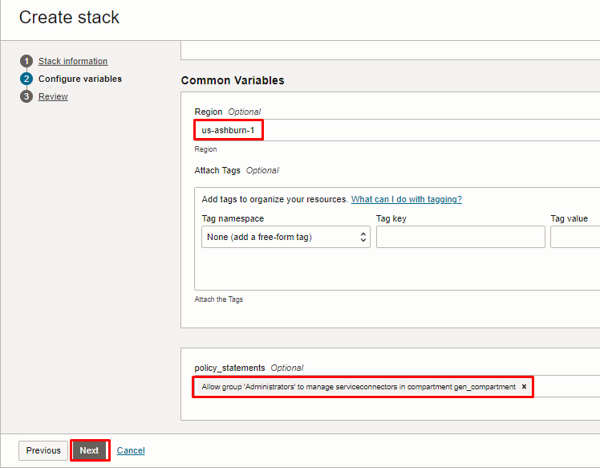

Note: select the right compartment to apply the stack in the OCI

Click “NEXT” Click “CREATE”
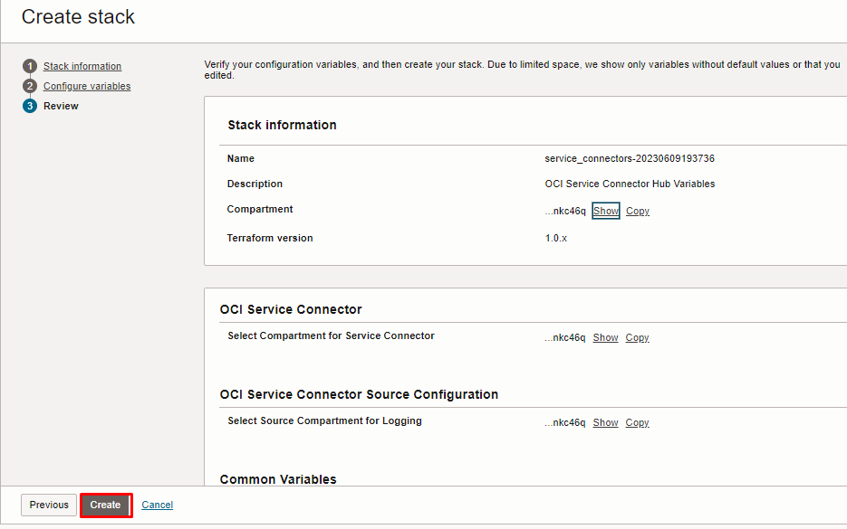

Plan the Job

Click the “Plan”

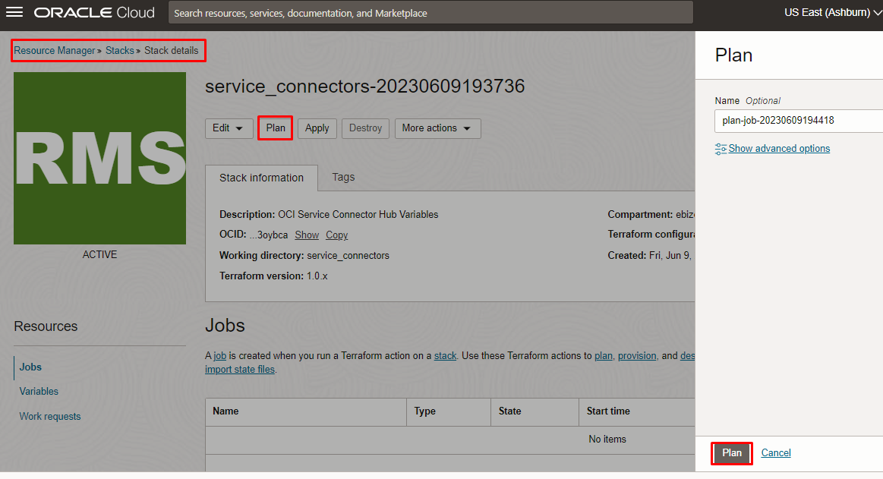

Verify the Plan is successful.

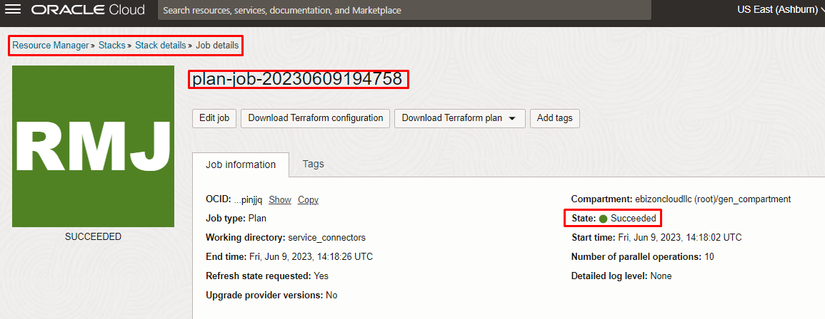
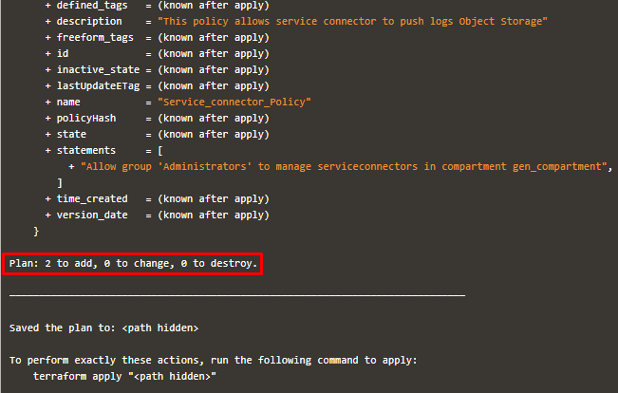

Apply the Job

Once the “plan” is success, now click “Apply”

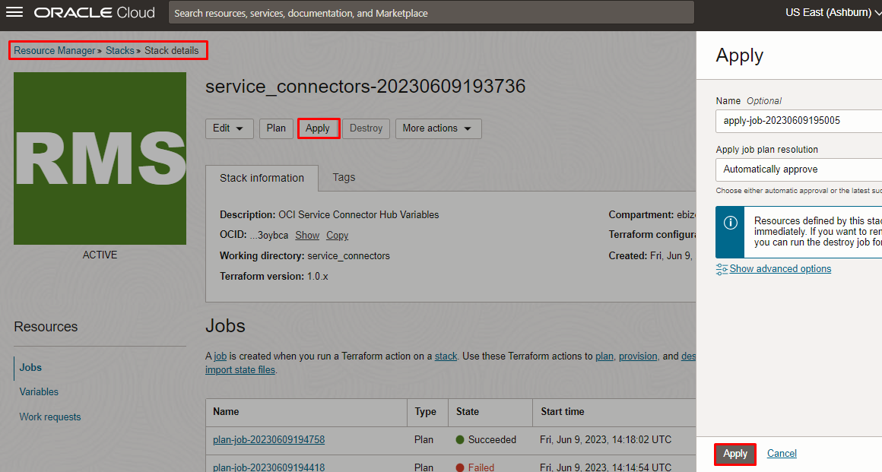

Verify the Apply is successful.

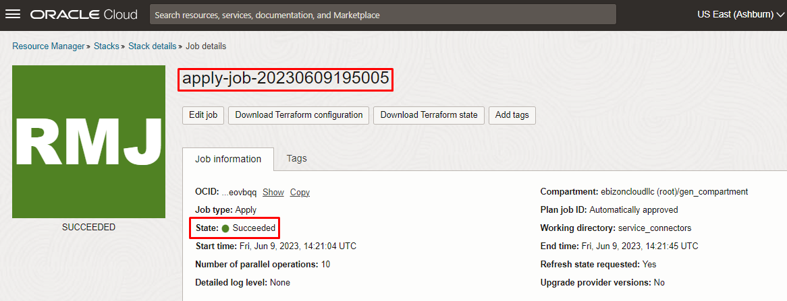
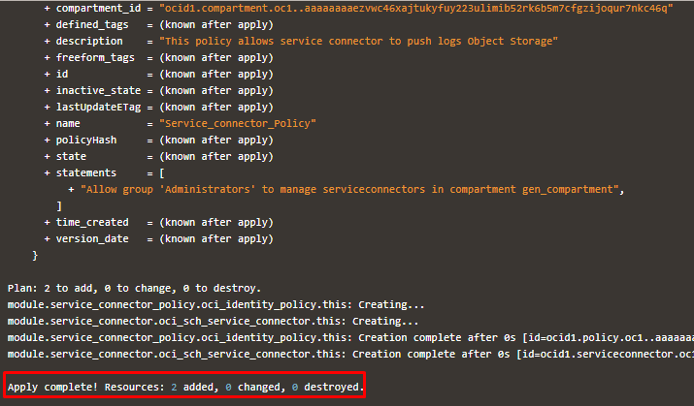

Verify in the Console

Go to OCI Console Observability & Management Logging Service Connectors
Note: Select the specified compartment (in the step 2) to get the output.

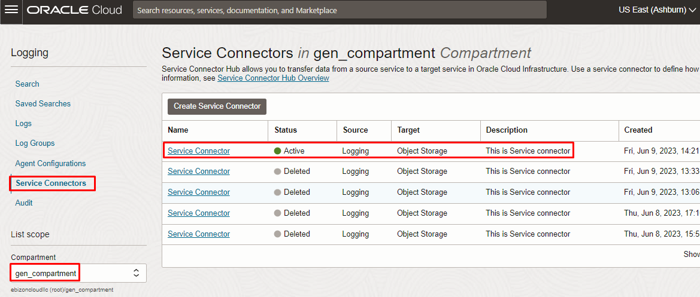

Destroy the stack (if required)

Create a destroy job in Resource Manager to release resources associated with a stack and clean up the tenancy. Once destroyed data cannot be recovered from resources.

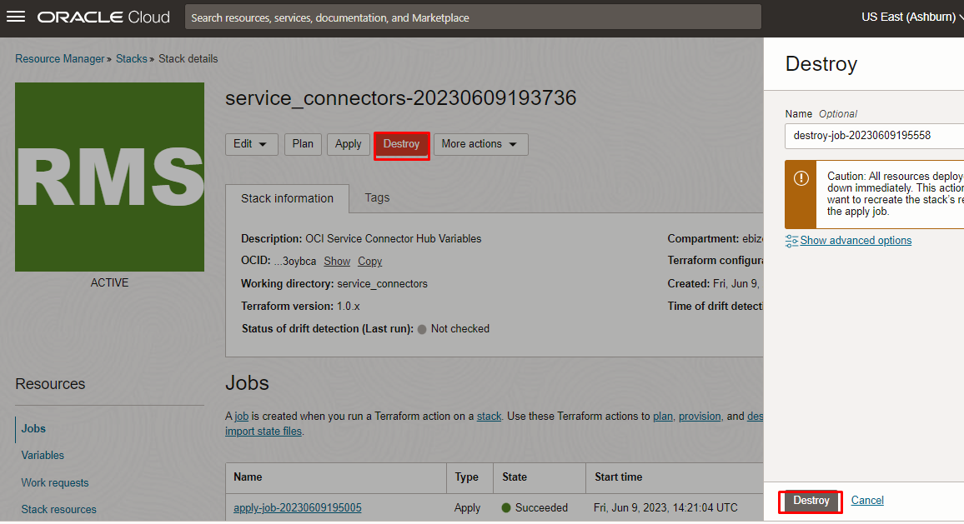

# END #

